ФЕДЕРАЛЬНОЕ АГЕНТСТВО ПО ОБРАЗОВАНИЮ
ОРЛОВСКИЙ ГОСУДАРСТВЕННЫЙ УНИВЕРСИТЕТ им. И.С. ТУРГЕНЕВА

Кафедра информационных системы и цифровых технологий

О Т Ч Е Т
о выполнении лабораторной работы № 1-4
по дисциплине «Выпуск и сопровождение программных продуктов»

Выполнили: Банных Мария Алексеевна Шифр: 220885
Мельников Артём Евгеньевич Шифр: 220896

Факультет (Институт) ИПАИТ
Направление / специальность: Программная инженерия
Группа:21ПГ
Преподаватели: Олькина Елена Викторовна
Булгакова Софья Андреевна
Отчет защищен «_________________»

Результат работы программы
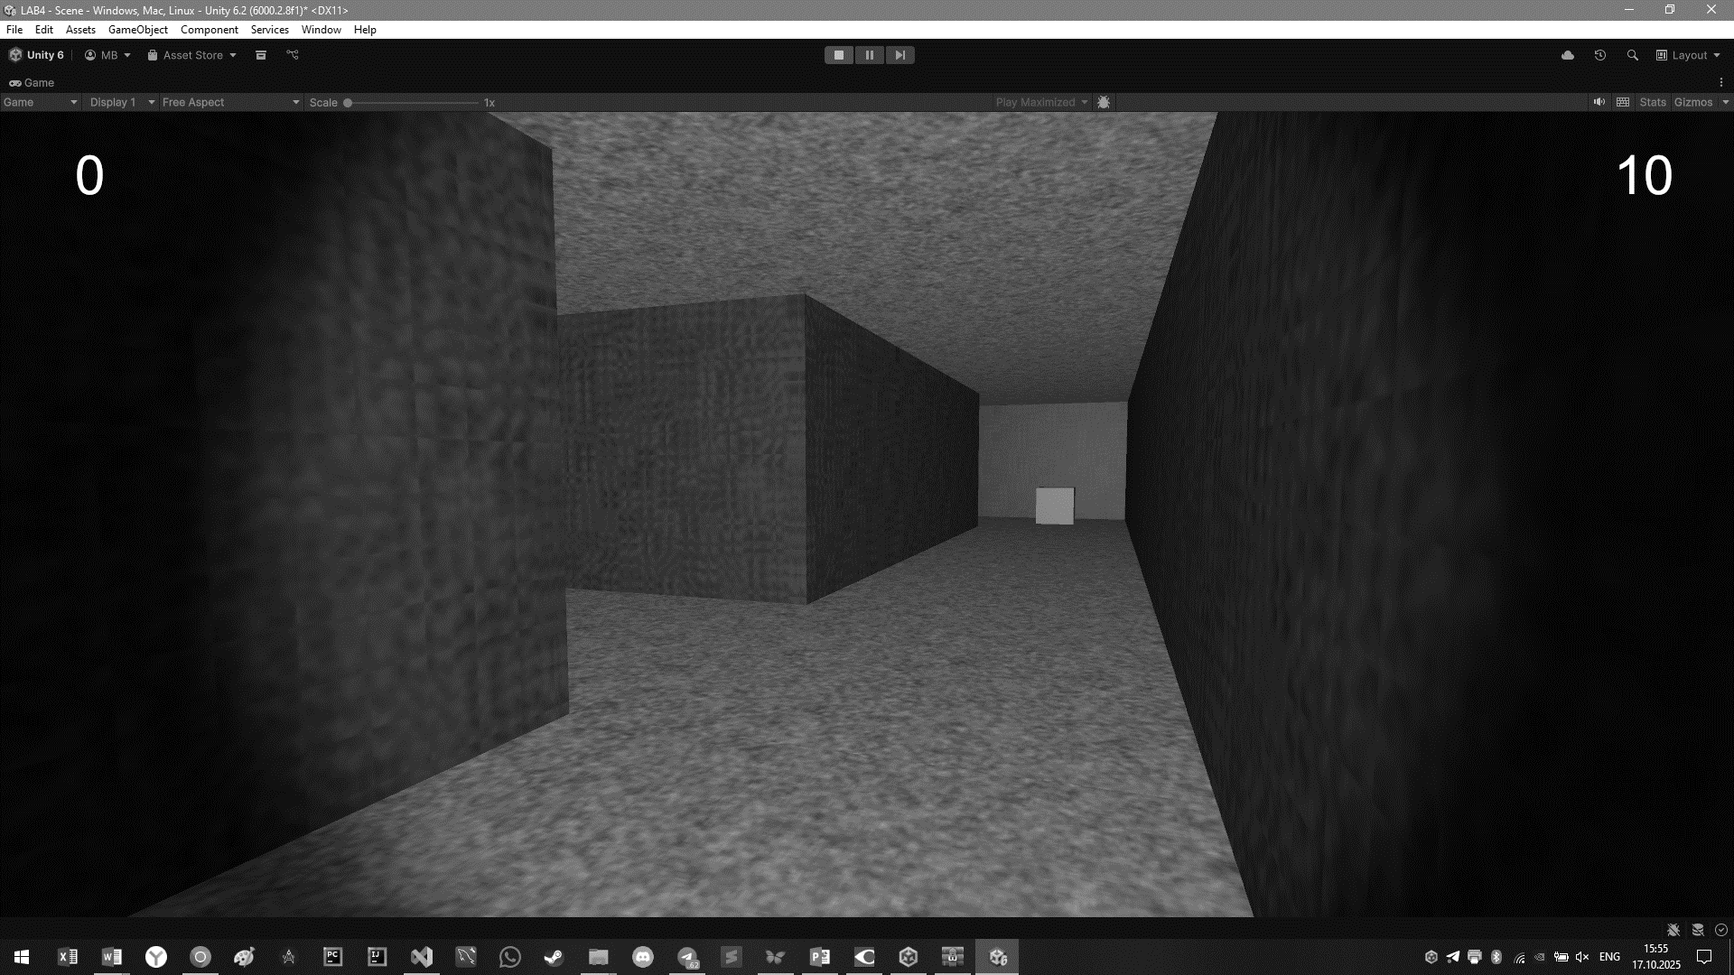
Листинг кода
Файл FpsMovement.cs:
/*
* written by Joseph Hocking 2017
* released under MIT license
* text of license https://opensource.org/licenses/MIT
*/

using System.Collections;
using System.Collections.Generic;
using UnityEngine;

[RequireComponent(typeof(CharacterController))]

// basic WASD-style movement control
public class FpsMovement : MonoBehaviour
{
[SerializeField] private Camera headCam;

public float speed = 6.0f;
public float gravity = -9.8f;

public float sensitivityHor = 2.0f;
public float sensitivityVert = 2.0f;

public float minimumVert = -45.0f;
public float maximumVert = 45.0f;

private float rotationVert = 0;

private CharacterController charController;

void Start()
{
charController = GetComponent<CharacterController>();
}

void Update()
{
MoveCharacter();
RotateCharacter();
RotateCamera();
}

private void MoveCharacter()
{
float deltaX = Input.GetAxis("Horizontal") * speed;
float deltaZ = Input.GetAxis("Vertical") * speed;

Vector3 movement = new Vector3(deltaX, 0, deltaZ);
movement = Vector3.ClampMagnitude(movement, speed);

movement.y = gravity;
movement *= Time.deltaTime;
movement = transform.TransformDirection(movement);

charController.Move(movement);
}

private void RotateCharacter()
{
transform.Rotate(0, Input.GetAxis("Mouse X") * sensitivityHor, 0);
}

private void RotateCamera()
{
rotationVert -= Input.GetAxis("Mouse Y") * sensitivityVert;
rotationVert = Mathf.Clamp(rotationVert, minimumVert, maximumVert);

headCam.transform.localEulerAngles = new Vector3(
rotationVert, headCam.transform.localEulerAngles.y, 0
);
}
}

Файл TriggerEventRouter.cs:
/*
* written by Joseph Hocking 2017
* released under MIT license
* text of license https://opensource.org/licenses/MIT
*/

using System.Collections;
using System.Collections.Generic;
using UnityEngine;

public delegate void TriggerEventHandler(GameObject trigger, GameObject other);

public class TriggerEventRouter : MonoBehaviour
{
public TriggerEventHandler callback;

void OnTriggerEnter(Collider other)
{
if (callback != null)
{
callback(this.gameObject, other.gameObject);
}
}
}

Файл GameController.cs:
using System;
using UnityEngine;
using UnityEngine.UI;

[RequireComponent(typeof(MazeConstructor))]

public class GameController : MonoBehaviour
{
//1
[SerializeField] private FpsMovement player;
[SerializeField] private Text timeLabel;
[SerializeField] private Text scoreLabel;

private MazeConstructor generator;

//2
private DateTime startTime;
private int timeLimit;
private int reduceLimitBy;

private int score;
private bool goalReached;

//3
void Start()
{
generator = GetComponent<MazeConstructor>();
StartNewGame();
}

//4
private void StartNewGame()
{
timeLimit = 80;
reduceLimitBy = 5;
startTime = DateTime.Now;

score = 0;
scoreLabel.text = score.ToString();

StartNewMaze();
}

//5
private void StartNewMaze()
{
generator.GenerateNewMaze(13, 15, OnStartTrigger, OnGoalTrigger);

float x = generator.startCol * generator.hallWidth;
float y = 1;
float z = generator.startRow * generator.hallWidth;
player.transform.position = new Vector3(x, y, z);

goalReached = false;
player.enabled = true;

// restart timer
timeLimit -= reduceLimitBy;
startTime = DateTime.Now;
}

//6
void Update()
{
if (!player.enabled)
{
return;
}

int timeUsed = (int)(DateTime.Now - startTime).TotalSeconds;
int timeLeft = timeLimit - timeUsed;

if (timeLeft > 0)
{
timeLabel.text = timeLeft.ToString();
}
else
{
timeLabel.text = "TIME UP";
player.enabled = false;

Invoke("StartNewGame", 4);
}
}

//7
private void OnGoalTrigger(GameObject trigger, GameObject other)
{
Debug.Log("Goal!");
goalReached = true;

score += 1;
scoreLabel.text = score.ToString();

Destroy(trigger);
}

private void OnStartTrigger(GameObject trigger, GameObject other)
{
if (goalReached)
{
Debug.Log("Finish!");
player.enabled = false;

Invoke("StartNewMaze", 4);
}
}
}

Файл MazeDataGenerator:
using System.Collections.Generic;
using UnityEngine;

public class MazeDataGenerator
{
public float placementThreshold; // chance of empty space

public MazeDataGenerator()
{
placementThreshold = .1f; // 1
}

public int[,] FromDimensions(int sizeRows, int sizeCols) // 2
{
int[,] maze = new int[sizeRows, sizeCols];
// stub to fill in
int rMax = maze.GetUpperBound(0);
int cMax = maze.GetUpperBound(1);

for (int i = 0; i <= rMax; i++)
{
for (int j = 0; j <= cMax; j++)
{
//1
if (i == 0 || j == 0 || i == rMax || j == cMax)
{
maze[i, j] = 1;
}

//2
else if (i % 2 == 0 && j % 2 == 0)
{
if (Random.value > placementThreshold)
{
//3
maze[i, j] = 1;

int a = Random.value < .5 ? 0 : (Random.value < .5 ? -1 : 1);
int b = a != 0 ? 0 : (Random.value < .5 ? -1 : 1);
maze[i + a, j + b] = 1;
}
}
}
}

return maze;
}
}

Файл MazeMeshGenerator.cs:
using System.Collections.Generic;
using UnityEngine;

public class MazeMeshGenerator
{
// generator params
public float width; // how wide are hallways
public float height; // how tall are hallways

public MazeMeshGenerator()
{
width = 3.75f;
height = 3.5f;
}

public Mesh FromData(int[,] data)
{
Mesh maze = new Mesh();

//3
List<Vector3> newVertices = new List<Vector3>();
List<Vector2> newUVs = new List<Vector2>();

maze.subMeshCount = 2;
List<int> floorTriangles = new List<int>();
List<int> wallTriangles = new List<int>();

int rMax = data.GetUpperBound(0);
int cMax = data.GetUpperBound(1);
float halfH = height * .5f;

//4
for (int i = 0; i <= rMax; i++)
{
for (int j = 0; j <= cMax; j++)
{
if (data[i, j] != 1)
{
// floor
AddQuad(Matrix4x4.TRS(
new Vector3(j * width, 0, i * width),
Quaternion.LookRotation(Vector3.up),
new Vector3(width, width, 1)
), ref newVertices, ref newUVs, ref floorTriangles);

// ceiling
AddQuad(Matrix4x4.TRS(
new Vector3(j * width, height, i * width),
Quaternion.LookRotation(Vector3.down),
new Vector3(width, width, 1)
), ref newVertices, ref newUVs, ref floorTriangles);

// walls on sides next to blocked grid cells

if (i - 1 < 0 || data[i - 1, j] == 1)
{
AddQuad(Matrix4x4.TRS(
new Vector3(j * width, halfH, (i - .5f) * width),
Quaternion.LookRotation(Vector3.forward),
new Vector3(width, height, 1)
), ref newVertices, ref newUVs, ref wallTriangles);
}

if (j + 1 > cMax || data[i, j + 1] == 1)
{
AddQuad(Matrix4x4.TRS(
new Vector3((j + .5f) * width, halfH, i * width),
Quaternion.LookRotation(Vector3.left),
new Vector3(width, height, 1)
), ref newVertices, ref newUVs, ref wallTriangles);
}

if (j - 1 < 0 || data[i, j - 1] == 1)
{
AddQuad(Matrix4x4.TRS(
new Vector3((j - .5f) * width, halfH, i * width),
Quaternion.LookRotation(Vector3.right),
new Vector3(width, height, 1)
), ref newVertices, ref newUVs, ref wallTriangles);
}

if (i + 1 > rMax || data[i + 1, j] == 1)
{
AddQuad(Matrix4x4.TRS(
new Vector3(j * width, halfH, (i + .5f) * width),
Quaternion.LookRotation(Vector3.back),
new Vector3(width, height, 1)
), ref newVertices, ref newUVs, ref wallTriangles);
}
}
}
}

maze.vertices = newVertices.ToArray();
maze.uv = newUVs.ToArray();

maze.SetTriangles(floorTriangles.ToArray(), 0);
maze.SetTriangles(wallTriangles.ToArray(), 1);

//5
maze.RecalculateNormals();

return maze;
}

//1, 2
private void AddQuad(Matrix4x4 matrix, ref List<Vector3> newVertices,
ref List<Vector2> newUVs, ref List<int> newTriangles)
{
int index = newVertices.Count;

// corners before transforming
Vector3 vert1 = new Vector3(-.5f, -.5f, 0);
Vector3 vert2 = new Vector3(-.5f, .5f, 0);
Vector3 vert3 = new Vector3(.5f, .5f, 0);
Vector3 vert4 = new Vector3(.5f, -.5f, 0);

newVertices.Add(matrix.MultiplyPoint3x4(vert1));
newVertices.Add(matrix.MultiplyPoint3x4(vert2));
newVertices.Add(matrix.MultiplyPoint3x4(vert3));
newVertices.Add(matrix.MultiplyPoint3x4(vert4));

newUVs.Add(new Vector2(1, 0));
newUVs.Add(new Vector2(1, 1));
newUVs.Add(new Vector2(0, 1));
newUVs.Add(new Vector2(0, 0));

newTriangles.Add(index + 2);
newTriangles.Add(index + 1);
newTriangles.Add(index);

newTriangles.Add(index + 3);
newTriangles.Add(index + 2);
newTriangles.Add(index);
}

}

Файл MazeConstructor.cs:
using UnityEngine;

public class MazeConstructor : MonoBehaviour
{
//1
public bool showDebug;

[SerializeField] private Material mazeMat1;
[SerializeField] private Material mazeMat2;
[SerializeField] private Material startMat;
[SerializeField] private Material treasureMat;
private MazeDataGenerator dataGenerator;
private MazeMeshGenerator meshGenerator;
public float hallWidth
{
get; private set;
}
public float hallHeight
{
get; private set;
}

public int startRow
{
get; private set;
}
public int startCol
{
get; private set;
}

public int goalRow
{
get; private set;
}
public int goalCol
{
get; private set;
}

//2
public int[,] data
{
get; private set;
}

//3
void Awake()
{
meshGenerator = new MazeMeshGenerator();
dataGenerator = new MazeDataGenerator();
// default to walls surrounding a single empty cell
data = new int[,]
{
{1, 1, 1},
{1, 0, 1},
{1, 1, 1}
};
}

public void GenerateNewMaze(int sizeRows, int sizeCols,
TriggerEventHandler startCallback = null, TriggerEventHandler goalCallback = null)
{
if (sizeRows % 2 == 0 && sizeCols % 2 == 0)
{
Debug.LogError("Odd numbers work better for dungeon size.");
}

DisposeOldMaze();

data = dataGenerator.FromDimensions(sizeRows, sizeCols);

FindStartPosition();
FindGoalPosition();

// store values used to generate this mesh
hallWidth = meshGenerator.width;
hallHeight = meshGenerator.height;

DisplayMaze();

PlaceStartTrigger(startCallback);
PlaceGoalTrigger(goalCallback);
}

void OnGUI()
{
//1
if (!showDebug)
{
return;
}

//2
int[,] maze = data;
int rMax = maze.GetUpperBound(0);
int cMax = maze.GetUpperBound(1);

string msg = "";

//3
for (int i = rMax; i >= 0; i--)
{
for (int j = 0; j <= cMax; j++)
{
if (maze[i, j] == 0)
{
msg += "....";
}
else
{
msg += "==";
}
}
msg += "\n";
}

//4
GUI.Label(new Rect(20, 20, 500, 500), msg);
}

private void DisplayMaze()
{
GameObject go = new GameObject();
go.transform.position = Vector3.zero;
go.name = "Procedural Maze";
go.tag = "Generated";

MeshFilter mf = go.AddComponent<MeshFilter>();
mf.mesh = meshGenerator.FromData(data);

MeshCollider mc = go.AddComponent<MeshCollider>();
mc.sharedMesh = mf.mesh;

MeshRenderer mr = go.AddComponent<MeshRenderer>();
mr.materials = new Material[2] { mazeMat1, mazeMat2 };
}

public void DisposeOldMaze()
{
GameObject[] objects = GameObject.FindGameObjectsWithTag("Generated");
foreach (GameObject go in objects)
{
Destroy(go);
}
}

private void FindStartPosition()
{
int[,] maze = data;
int rMax = maze.GetUpperBound(0);
int cMax = maze.GetUpperBound(1);

for (int i = 0; i <= rMax; i++)
{
for (int j = 0; j <= cMax; j++)
{
if (maze[i, j] == 0)
{
startRow = i;
startCol = j;
return;
}
}
}
}
private void FindGoalPosition()
{
int[,] maze = data;
int rMax = maze.GetUpperBound(0);
int cMax = maze.GetUpperBound(1);

// loop top to bottom, right to left
for (int i = rMax; i >= 0; i--)
{
for (int j = cMax; j >= 0; j--)
{
if (maze[i, j] == 0)
{
goalRow = i;
goalCol = j;
return;
}
}
}
}
private void PlaceStartTrigger(TriggerEventHandler callback)
{
GameObject go = GameObject.CreatePrimitive(PrimitiveType.Cube);
go.transform.position = new Vector3(startCol * hallWidth, .5f, startRow * hallWidth);
go.name = "Start Trigger";
go.tag = "Generated";

go.GetComponent<BoxCollider>().isTrigger = true;
go.GetComponent<MeshRenderer>().sharedMaterial = startMat;

TriggerEventRouter tc = go.AddComponent<TriggerEventRouter>();
tc.callback = callback;
}

private void PlaceGoalTrigger(TriggerEventHandler callback)
{
GameObject go = GameObject.CreatePrimitive(PrimitiveType.Cube);
go.transform.position = new Vector3(goalCol * hallWidth, .5f, goalRow * hallWidth);
go.name = "Treasure";
go.tag = "Generated";

go.GetComponent<BoxCollider>().isTrigger = true;
go.GetComponent<MeshRenderer>().sharedMaterial = treasureMat;

TriggerEventRouter tc = go.AddComponent<TriggerEventRouter>();
tc.callback = callback;
}

}

